1.Question 1

What are the three parts to a problem?



(a). The initial state, solution path and goal

2.Question 2

Consider the following problem from a university course:

“In 2006, Mt Red High School, a public school in Sydney’s inner-west, ranked 1st in NSW for HSC Physics and Biology. Since 2013, however, there has been a sharp decline in Physics scores and this year only 3 students signed up for the course. A study was done that indicates students are losing interest in Science during year 9. Design a curriculum outline with the aim of increasing interest in Science. Your curriculum outline should include the sequence of units, descriptions of each unit, and all assessments for the course.”

What is the goal of this problem?



(c). To design a year 9 Science curriculum to increase student interest in science

3.Question 3

What is a knowledge-lean problem?

(c). A problem where little to no prior knowledge is needed to solve it

1.Question 1

Where are you most likely to find a descriptive task or problem?

*Check two options.*



(a). At the beginning of a test or exam



(c). Embedded into analytical questions

2.Question 2

How much are descriptive tasks or problems worth in relation to other types of assessment in terms of grades?

(c). Descriptive tasks and problems are usually worth less marks than other types of assessment.

3.Question 3

Which of the following are descriptive tasks or simple problems?



(b). List the symptoms of the common cold.



(c). Given an isosceles triangle with two side measuring 5cm each and one side measuring 6cm, find the area inside the triangle.



(d). According to the 2007 census results, what percentage of Australian’s identify as religious?

1.Question 1

The difference between an analytical task and a descriptive task is…

(b). A descriptive task asks for you to present knowledge or facts whereas an analytical task asks for new knowledge creation or interpretation by the respondent.

2.Question 2

“Shakespeare’s legacy to successive generations is his firm faith in human potential. His writing challenges us to reach beyond our grasp and gives us the wherewithal to imagine our future (Bell Shakespeare Company, 2016). Discuss with reference to *Hamlet*.

(b). An analytical task

3.Question 3

Consider the following question from a university course:

“Examine the use of electronic voting system *Votomatic* in the 2000 Florida US presidential elections. Should they be used in future elections in order to speed up the slow processing of paper ballots?”

This is an example of:

(b). An analytical problem

1.Question 1

Consider the following simple problem.

“Given an isosceles triangle with two sides measuring 5cm each and one side measuring 6cm, find the area inside the triangle.”

What would be the first step in solving this problem?

(a). Draw an isosceles triangle with two equal sides of 5cm and one side of 6cm.

2.Question 2

Consider the following problem given in the lesson for 2.2a:

"

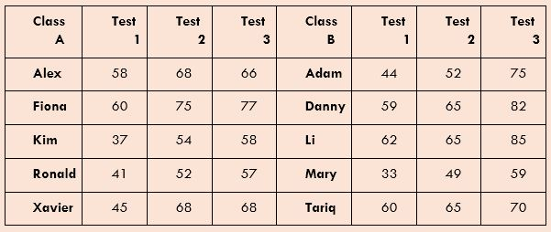

A) Find each class’ average mark for each test."

What would be the last step you would do before handing this question in to be marked?

(c). Double-check your results and make sure that they make sense with the data.

3.Question 3

In the Design Thinking model of problem-solving, what does ‘iterative’ mean?



(b). Adapting or changing a strategy or solution until you find the best solution to the problem